**COMPANY PROFILE**

1. **Company Name MS Maelys Solutions**
2. **Company Overview**

MS Maelys Solutions Sarl Is a multi-disciplinary engineering and construction company specializing in Electrical & Instrumentation, Civil Engineering, Mechanical Engineering, Piping and Steel Fabrication, and Infrastructure Development. We deliver turnkey solutions across industrial, commercial, mining and public infrastructure projects with a focus on quality, safety, innovation, and client satisfaction

Our team of qualified engineers, technicians, and skilled artisans ensures that every project in completed on time, within budget, and to highest international standards

1. **Vision**

To be a leading engineering and construction company in Africa and beyond, delivering sustainable infrastructure and industrial solutions that power progress and innovation

1. **Mission**

To provide reliable, cost-effective and high-quality engineering services through innovation, teamwork, and continuous improvement while maintaining the highest safety and environmental standards

1. **Core Values**

* Integrity- We conduct business ethically and transparently
* Quality- We uphold excellence in every aspect of our work
* Safety- We prioritize the health and safety of all stakeholders
* Innovation- We embrace technology and creativity in our solutions
* Sustainability- We promote eco-friendly and long-lasting solutions
* Customer Service- We tailor our services to meet each client’s needs

1. **Our Services**

**Electrical & Instrumentation**

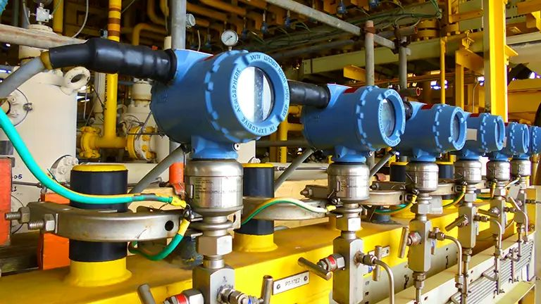

* Industrial, mining and commercial electrical installations
* Cable laying, termination, and testing
* Control panel design and installations
* SCADA and automation systems
* Instrument calibration and loop checking
* Power distribution and lighting systems
* Maintenance and troubleshooting
* Plc maintenance and programming

**Civil Engineering**

* Structural design and construction
* Concrete works and foundations
* Road construction and drainage systems
* Water and sewer reticulation
* Building construction and rehabilitation
* Earthworks and site preparation

**Piping, Steel, and HDP Works**

* Piping fabrication and installation (carbon steel, stainless steel, HDPE)
* Pipeline testing, flushing and commissioning
* Structural steel fabrication and erection
* Tank fabrication and repairs

**Infrastructure Building, Plastering & Painting**

* Residential, commercial and industrial buildings
* Roofing, tiling, and interior finishing
* Renovations and maintenance works
* Road surfacing and pavement construction

**Mechanical Engineering**

* Mechanical design and installation
* Pumps, valves and compressor installation
* Equipment alignment and commissioning
* Maintenance and overhaul of mechanical systems
* Fabrication of mechanical structures and component

**Plant Hire and Earth Moving**

* Hiring of mobile crane, trucks, front loaders, fork lifter and cherry picker

1. **Health, Safety & Environmental (HSE)**

MS Maelys Solutions maintains a strong commitment to Zero Harm in all operations. Our HSE management system ensures compliance with local and international safety standards, providing safe working environments for all personnel and subcontractors

1. **Quality Assurance**

We implement a Quality Management System (QMS) aligned the ISO 9001-2015 standards to ensure that every project meets client specifications and regulatory requirements. Regular audits, testing, and documentation ensure continuous improvement and client satisfaction

1. **Key Clients**

Mining and Industrial Companies

Energy and Power utilities

Construction and Engineering Consultants

Government Ministries

Private Developers

1. **Contact Information**

Director: Richard Mutombo

Email: [maelyssolutions@gmail.com](mailto:maelyssolutions@gmail.com)

Phone: +243970018638